

FACULTY OF INFORMATION AND COMMUNICATION TECHNOLOGY
MODULE101

Title : Design Logical Solutions for Sierra Leone Community Challenges
Issue Date : Week 2
Due Date : Week 4
Lecturer/Examiner : Mr. Elijah Fullah
Name of Student : JOSEPH CALVIN TURAY
Student ID No. : 905005832
Class : B.S.E.M. 1101
Semester/Year : 1/1

Academic Honesty Policy Statement

I/We, hereby attest those contents of this attachment are my own work. Referenced works, articles, art, programs, papers or parts thereof are acknowledged at the end of this paper. This includes data excerpted from CD-ROMs, the Internet, other private networks, and other people’s disk of the computer system.

Student’s Signature: Date: 30th September 2026
LECTURER’S COMMMENTS/GRADE:

for office use only upon receive
Remark

DATE :
TIME :
RECEIVER’S NAME :

Table of Contents
ABSTRACT 3
INTRODUCTION 4
CONTENT ANALYSIS 5
Rationale 5
Algorithm 7
Pseudocode 8
Flowcharts 9
Functional Modules 9
Expected Outputs 10
GitHub Evidence 11
CONCLUSION 12
REFERENCES 13

ABSTRACT

This academic report presents a comprehensive, non-code logical solution designed to address the interconnected challenges of urban waste accumulation, drainage clogging, and localized flooding in Freetown, Sierra Leone. The introduction highlights Freetown’s geographic vulnerability to torrential rain and drainage blockage, establishing the need for computational thinking and logical software modelling before coding. The core content analysis details an algorithm-driven decision support system that applies problem decomposition, pattern recognition, abstraction, and modular design to evaluate real-time rainfall and blockage metrics. Using step by step algorithms, simplified pseudocode, and flowchart logic, the system processes input variables through decision and trigger automated alert levels. The report evaluates the system’s integration with UN Sustainable Development Goals (SDGs) and justifies its development as Open Source Software and a Digital Public Good (DPG) to promote community access and long term disaster resilience. Ultimately, the conclusion confirms that quantitative logical modeling effectively bridges the gap between community environmental hazards and digital response systems without low-level code complexity. The report draws upon foundational principles in programming logic, sustainable development frameworks, and local disaster management policies.

INTRODUCTION

Sierra Leone faces severe environmental and infrastructural pressures due to rapid urban expansion, heavy seasonal rainfall, and high population density in coastal cities such as Freetown. The geography of Freetown characterized by steep hillsides draining into densely populated coastal lowland settlements makes the urban area exceptionally vulnerable to rapid runoff during the annual monsoon season. A primary amplifier of urban flood disaster risks is the accumulation of uncollected municipal solid waste and plastic debris within stormwater drainage channels and natural waterways. When heavy rain events coincide with clogged drainage channels, localized flash flooding occurs within minutes, destroying informal housing, disrupting transport networks, threatening livelihoods, and increasing water borne disease risks.

To address these vulnerabilities, traditional approaches relying solely on manual, reactive clearing operations have proven insufficient. Prior to software development, engineering effective digital solutions requires rigorous problem details the complete logical design for the Urban Waste Clogging and Flood Risk Early Warning System (UWCF-EWS); an algorithm-driven decision support framework engineered to ingest community-reported drainage blockage levels and continuous rainfall telemetry, process real-time risk scores, and output localized alert levels alongside automated municipal dispatch actions.
The main objectives of this project are:
- To decompose the complex environmental challenge of urban flood risks in Sierra Leone into solvable computational modules.
- To formulate robust algorithm logic, pseudocode, and flowchart structures utilizing modular functions, decision structures, and repetition loops.
- To evaluate the deployment of the design as an Open Source Software project and Digital Public Good (DPG) aligned with UN Sustainable Development Goals.
- To establish transparent project, management and version control workflows via Git and GitHub.

CONTENT ANALYSIS

Rationale

Problem Analysis
In many informal settlements across Freetown, such as Kroo Bay, Susan's Bay, and Kulakaray stormwater channels serve as informal disposal sites for domestic solid waste due to limited municipal collection infrastructure. During heavy downpours, accumulated waste is swept into narrow drainage conduits, culverts, and bridges. This creates massive blockages that impede natural hydraulic discharge, causing torrents of floodwater to overflow into surrounding neighborhoods.

- Who is Affected: Informal settlement dwellers, market traders, urban commuters, municipal sanitation workers, and emergency response authorities.

- Why the Problem Exists: Inadequate waste management facilities, limited real-time monitoring of channel conditions, high precipitation rates during rainy seasons, and lack of automated early warning mechanisms.

- Proposed Solution: A modular logical pipeline that aggregates drainage clogging data (expressed as a percentage) and hourly precipitation levels (in millimeters), computes a composite Risk Index, and generates automated risk categories with actionable intervention steps.

Background
Freetown experiences high annual rainfall concentrated within intense monsoon months. The steep topography accelerates surface runoff into natural drainage channels that cut through informal settlements before reaching the Atlantic Ocean. Years of rapid urbanization, inadequate waste disposal systems, and lack of automated environmental telemetry have left community members reliant on visual observation during active rainfall, leading to delayed evacuations and preventable damage.

Community Impact
- Primary Beneficiaries: Informal settlement residents in low-lying micro-catchments (e.g., Kroo Bay, Susan's Bay, Kulakaray), local street/market traders, municipal sanitation workers, urban commuters, and the National Disaster Management Agency (NDMA).
- Disaster Mitigation & Early Warning: Provides real-time risk classification, allowing community members and local emergency responders to evacuate high-risk sectors prior to severe flash flooding.
- Targeted Solid Waste Clearing: Directs municipal clearing teams to specific blockage bottlenecks before heavy precipitation occurs, preventing storm runoff from overflowing drainage channels.
- Public Health & Disease Reduction: Minimizes stagnant floodwaters laden with solid waste, directly reducing the incidence of waterborne diseases such as cholera, typhoid, and malaria in high-density urban areas.
- Economic Preservation & Infrastructure Protection: Safeguards informal housing units, small business inventory in coastal markets, and vital transport links against physical water damage and silt accumulation.
- Long-Term Civic Engagement: Empowers youth groups and community disaster management committees (CDMCs) to systematically monitor and report local drainage conditions, fostering proactive civic stewardship.

Proposed Solution
The proposed solution is the Urban Waste Clogging and Flood Risk Early Warning System (UWCF-EWS), a platform-neutral logical architecture that aggregates drainage blockage percentages (B ) and precipitation rates (P ) calculates a composite Risk Index, and maps the results into automated alert tiers with explicit operational directives.

Computational Thinking Process
The logical construction relies on four core pillars of computational thinking:
- Decomposition: Breaking urban flood monitoring into data ingestion, risk processing, and alert dispatching.
- Pattern Recognition: Identifying that drain blockage over 60% paired with precipitation above 30 mm/hr creates critical flood hazards.
- Abstraction: Filtering out extraneous environmental variables to focus on quantifiable parameters: rainfall rate (P ), blockage ratio (B ) and risk score (S).
- Algorithm Design: Designing input-to-output workflows using explicit sequencing, decision logic (IF-THEN-ELSE), conditional loops (WHILE), and modular functions.

Algorithm Design Summary
The algorithmic workflow validates input telemetry, executes weighted scoring routines, evaluates conditional alert thresholds, and produces formatted community status reports.

Sustainability Development Goal (SDG) Alignment
SDG 11: Sustainable Cities and Communities (Target 11.5): The system directly addresses Target 11.5 by establishing an early warning and blockage-monitoring solution designed to significantly reduce the number of urban residents affected by localized flash floods and municipal drainage failures in Freetown.

Open Source Justification
Deploying under an open-source license (e.g., MIT) eliminates recurring licensing expenses for district councils, permits community auditing, and enables local software engineering students and tech hubs in Freetown to adapt the logic for other local catchments.

Digital Public Goods Justification
The system satisfies Digital Public Good requirements through its platform-agnostic design, adherence to open standards, focus on public disaster mitigation, and open distribution for all Sierra Leonean municipalities without restriction.

Algorithm
- START execution.
- Declare variables (communityID, rainfallRate, blockagePercent, riskScore, alertLevel) and set loop flag continueInput = TRUE.
- WHILE continueInput is TRUE:
a. Ask for and read communityID.
b. Read and validate rainfallRate (must be 0 or greater).
c. Read and validate blockagePercent (must be between 0 and 100).
d. Calculate riskScore using CalculateRiskScore(rainfallRate, blockagePercent). e. Determine alertLevel using DetermineAlertLevel(riskScore).
f. Display the assessment report using DisplayRiskReport(...).
g. Ask if the user wants to evaluate another sector. If the response is "NO", set continueInput = FALSE.
- END WHILE.
- Display shutdown message and STOP.

Pseudocode
Flood & Waste Risk Warning System
- START
- String community
- Real rain, blockage, risk
- String level, choice
- Boolean run = TRUE
- WHILE run == TRUE DO
- DISPLAY "Enter community name:"
- INPUT community
- DISPLAY "Enter rainfall in mm/hr:"
- INPUT rain
- DISPLAY "Enter drain blockage percentage (0-100):"
- INPUT blockage
- IF rain < 0 OR blockage < 0 OR blockage > 100 THEN
- DISPLAY "Error: Invalid numbers entered."
- ELSE
- risk = (rain * 0.6) + (blockage * 0.4)
- IF risk < 20 THEN
- level = "LOW" ELSE
- IF risk < 45 THEN level = "MODERATE"
- ELSE IF risk < 70 THEN
- level = "HIGH" ELSE level = "CRITICAL"
- END IF
- DISPLAY "Community: " + community
- DISPLAY "Risk Score: " + risk
- DISPLAY "Alert Level: " + level
- END IF
- DISPLAY "Analyze another community? (YES/NO):"
- INPUT choice
- IF choice == "NO" OR choice == "no" OR choice == “NO” OR choice == “n” OR choice == “N” THEN
- run = FALSE
- END IF
- END WHILE
- DISPLAY "System closed."
- END

Flowcharts

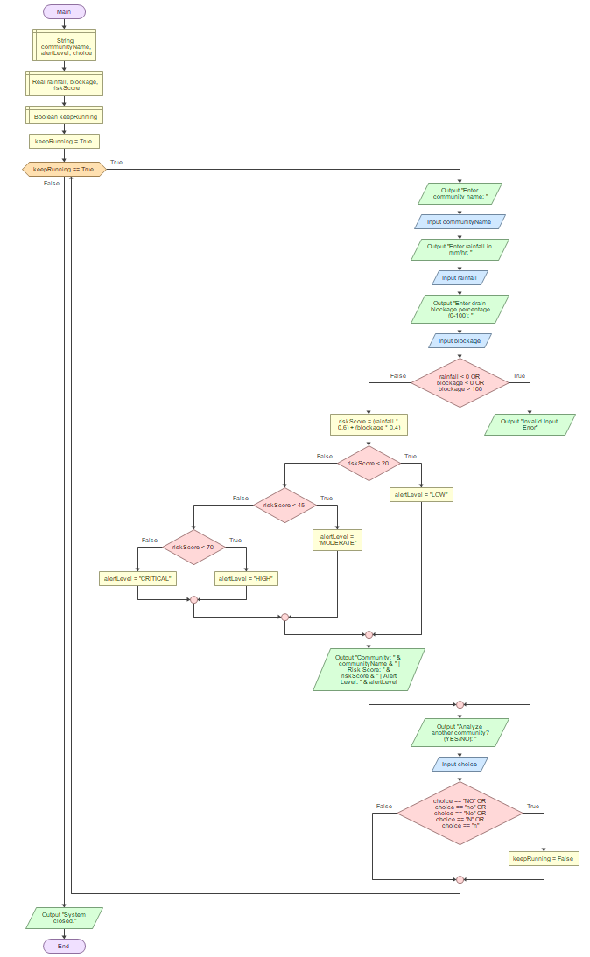

Functional Modules
- Function: CalculateRiskScore(rain, blockage)
- Parameters: Real rain, Real blockage
- Returns: Real
- Logic: Computes weighted sum Risk = (rain × 0.6) + (blockage × 0.4)

- Function: DetermineAlertLevel (riskScore)
- Parameters: Real riskScore
- Returns: String
- Logic: Maps numerical risk scores to discrete tiers (“LOW”, “MODERATE”, “HIGH”, “CRITICAL”).

- Module: DisplayRiskReport(community, rain, block, risk, level)
- Parameters: String community, Real rain, Real block, Real risk, String level
- Logic: Formats detailed hazard outputs and outputs municipal directives

Expected Outputs

Scenario 1: Routine Assessment (Light Rain)
- Inputs: communityName = "Kroo Bay", rainfall = 10.0, blockage = 25.0
- Output:
“Community: Kroo Bay
Risk Score: 16.0
Alert Level: LOW
Action: Normal maintenance required.”
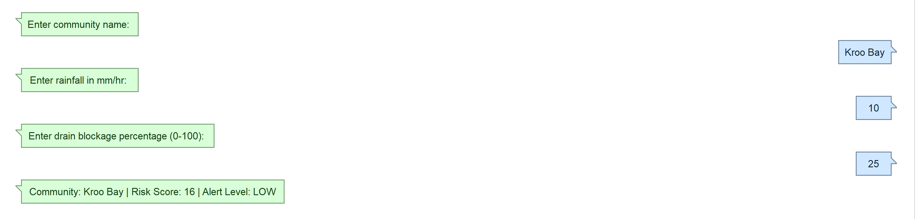

Scenario 2: Severe Threat (Heavy Downpour & Clogged Drain)
- Inputs: communityName = "Granite Ditch Kissy", rainfall = 55.0, blockage = 65.0
- Output:
“Community: Granite Ditch Kissy
Risk Score: 59.0
Alert Level: HIGH
Action: Dispatch cleanup teams immediately!”
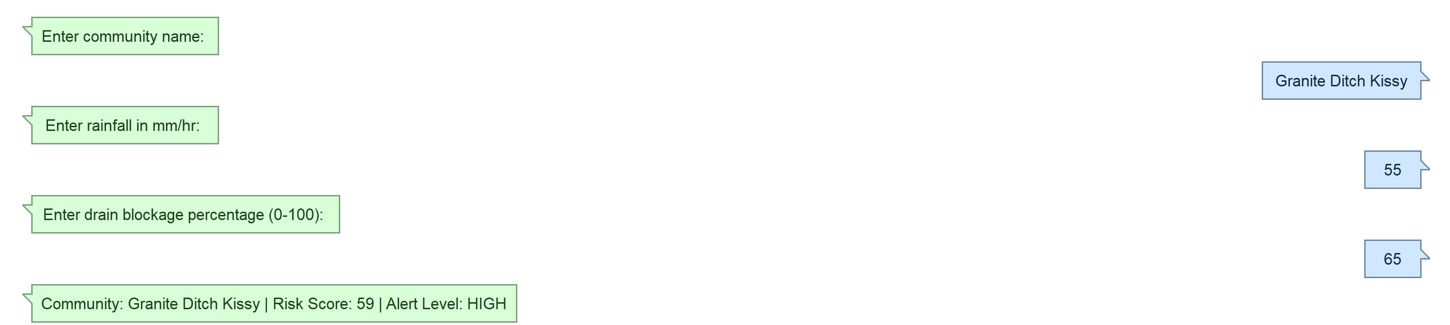

GitHub Evidence
  - RepositoryURL: https://github.com/defnotareader/PROG101_Assignment1_JosephCalvinTuray_905005832.git
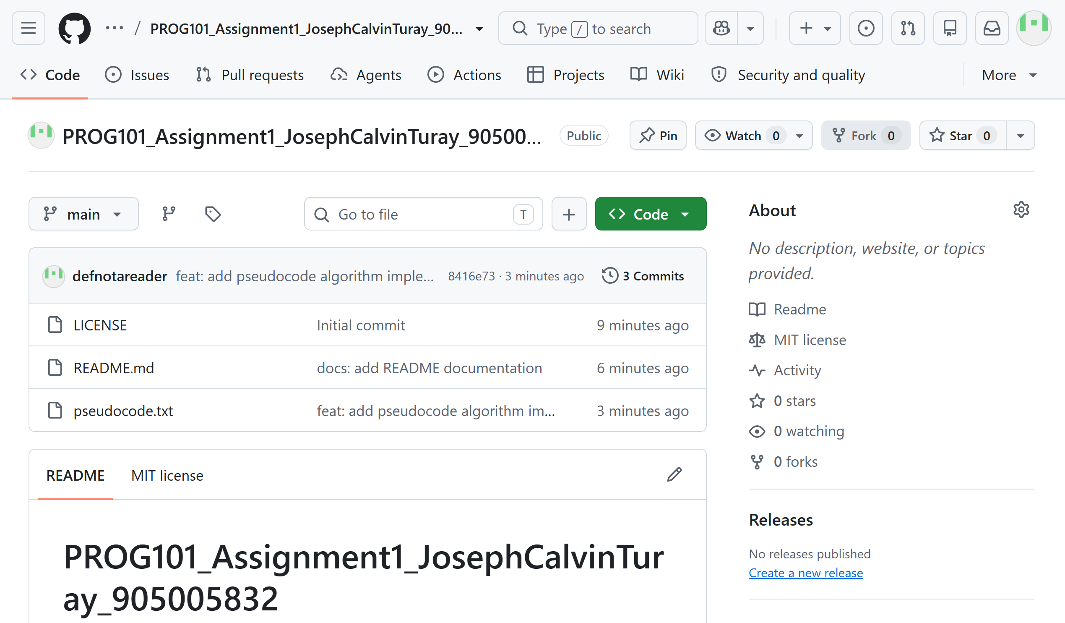

  - Commit History
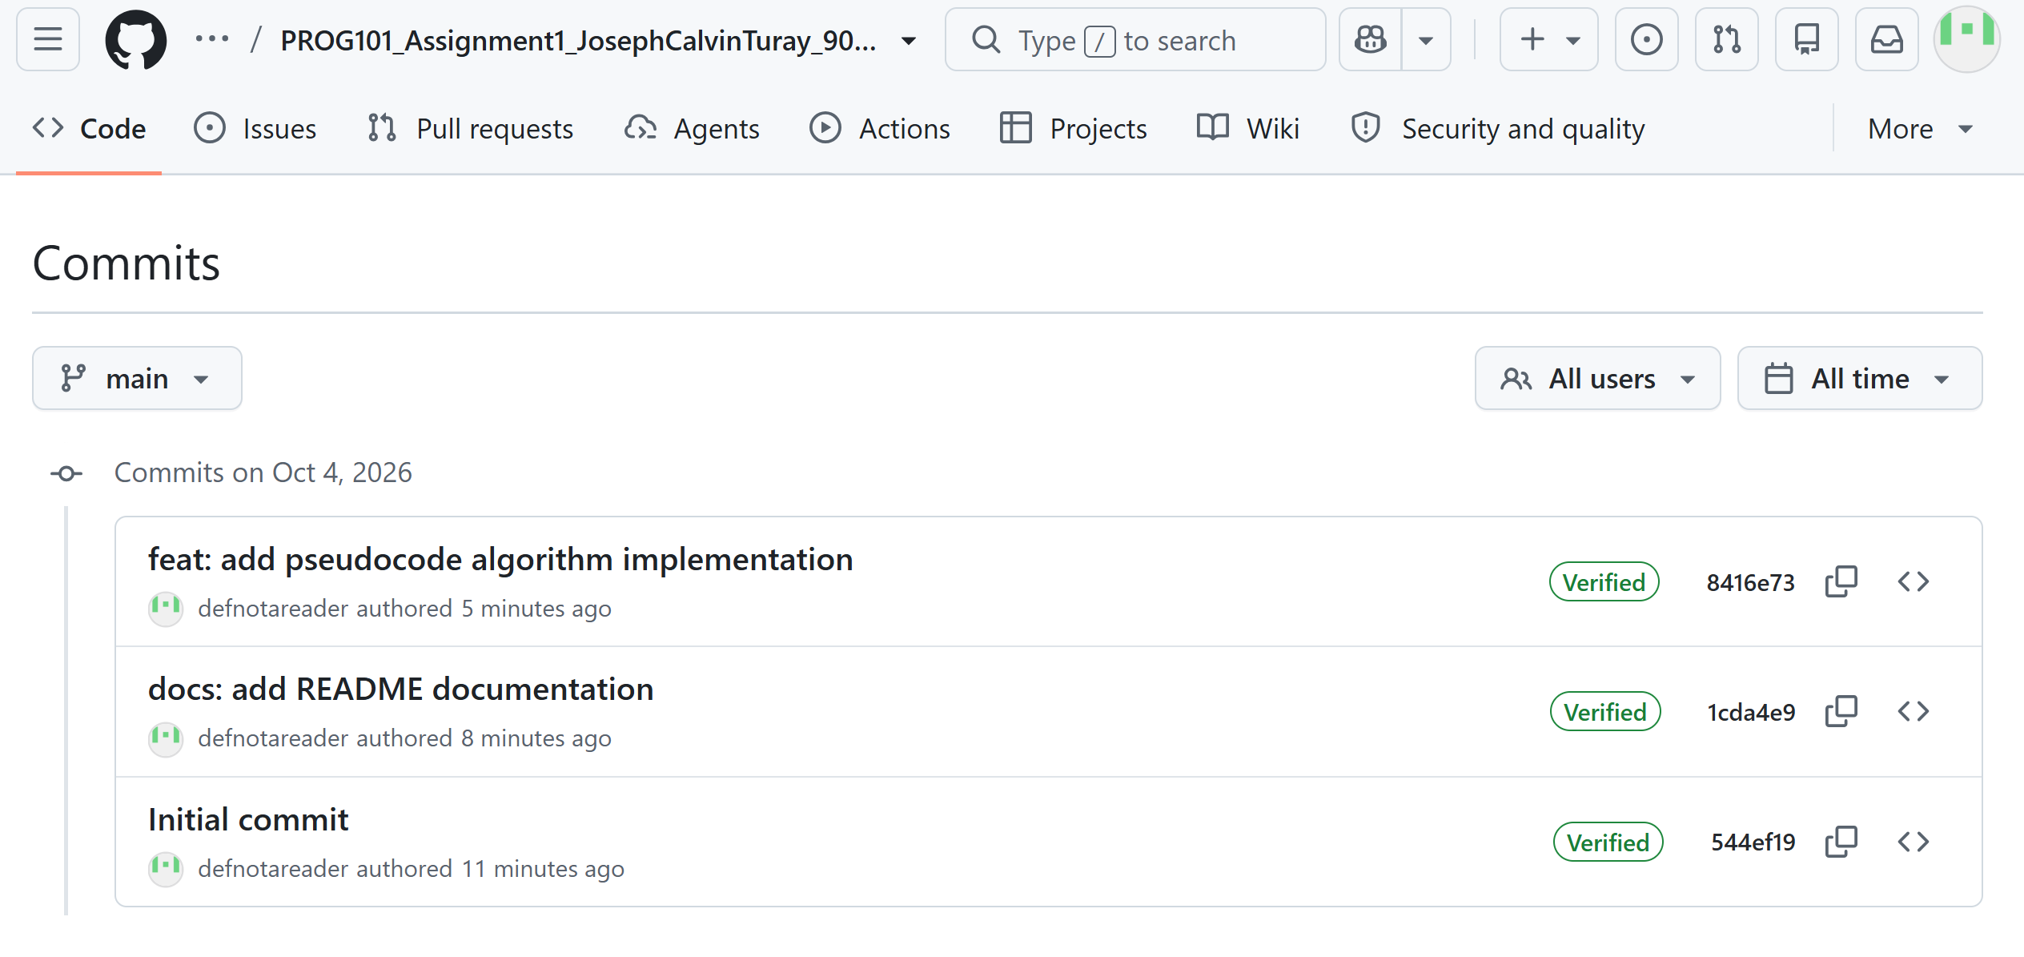

CONCLUSION

This project demonstrates the application of computational thinking and logical software design to solve urban waste clogging and flash flooding in Sierra Leone. By abstracting precipitation rates and drainage blockage ratios into a structured decision pipeline, a resilient early warning solution was constructed without writing low-level code. Through open-source alignment, Digital Public Goods frameworks, and United Nations Sustainable Development Goals, this model provides a practical blueprint for municipal safety and community disaster reduction.

REFERENCES

- Digital Public Goods Alliance, 2023. The Digital Public Goods Standard. DPG Alliance. Available at: https://digitalpublicgoods.net/standard/
- Freetown City Council, 2022. Transform Freetown: Final Report 2019-2022. Freetown: Freetown City Council.
- Gaddis, T., 2019. Starting Out with Programming Logic and Design. 5th ed. Boston: Pearson.
- Government of Sierra Leone, 2020. National Disaster Risk Management Policy. Freetown: Office of National Security (ONS).
- Sprankle, M. and Hubbard, J., 2012. Problem Solving and Programming Concepts. 9th ed. Boston: Prentice Hall.
- United Nations, 2015. Transforming Our World: The 2030 Agenda for Sustainable Development. New York: UN Publishing.
- Images uploaded from Flowgorithm.

